**A SUMMER INTERNSHIP REPORT**

**on**

**“Title’”**



**Submitted to Great Lakes Institute of Management, Tamil Nadu -603102**



**In partial fulfillment for the award**

**Of**

**POSTGRADUATE DIPLOMA IN MANAGEMENT (PGDM)**

**By**

|  |  |  |
| --- | --- | --- |
| **Roll No.** | **Name** | **Batch** |
| DM262009 | Ameya Pramod Ghagare | PGDM 2024-2026 |

**Under the Guidance of**

**Faculty Guide**

Institute Name: **Great Lakes Institute of Management, Chennai**

Guide Name: **<<Name Prefix>>.<< Full Name>>**

Designation: **<<Designation>>**

**Company Guide**

Company Name: **<<Full Company Name>>**

Guide Name: **<<Name Prefix>>.<< Full Name>>**

Designation: **<<Designation>>, <<Designation>> Department**

**DECLARATION**

I hereby declare that the Summer Internship report titled **“Title’”** is my own work to the best of my knowledge and belief. It contains no material previously published or written by another person or material which to substantial extent has been accepted for the award of any other degree, diploma or program of any other institute, except where due acknowledgement has been made in text.

*(Student’s Signature)*

Date**:**  Student’s Name : Ameya Pramod Ghagare

Student’s Roll No:DM262009

Batch : **PGDM 2024 - 2026**

**[i]**

**BONAFIDE CERTIFICATE**

This is to certify that the Summer Internship report titled “**Title’”,** is a piece of bonafide work of Sridhar R (DM24032), under my guidance and supervision for the partial fulfilment of Post Graduate Diploma in Management, a Program offered by Great Lakes Institute of Management, Chennai.

To the best of my knowledge and belief the Summer Internship report:

1. embodies the work of the candidate himself / herself
2. has duly been completed
3. fulfills the requirements of the Rules & Regulations relating to the Summer Internship of the Institute.
4. is up to the standard both in respect to contents and language for being referred to the examiner

(Professor’s Signature)

Date**:**  Faculty Guide: <<Name Prefix>>.<< Full Name>>

**[ii]**

**ACKNOWLEDGEMENT**

I would like to express my sincere gratitude to the entire team at IMPACCT, a business division under ASAPP Info Global Services Pvt. Ltd., for providing me with the opportunity to work on live infrastructure intelligence projects. This experience has significantly enhanced my technical acumen and refined my analytical, problem-solving, and collaborative skills. The supportive environment and open learning culture at IMPACCT greatly contributed to my growth.

I am deeply grateful to Mr. Tanveer Padode, CIO of ASAPP Info Global, for his visionary leadership and for creating an environment that encourages innovation and continuous learning. His strategic insights and guidance were truly inspiring.

I would also like to thank my immediate supervisors, Mr. Jagdish Londe and Ms. Priyanka Chettiar, for their constant mentorship, timely feedback, and hands-on support throughout the internship. Their technical expertise and patient guidance played a pivotal role in helping me understand the nuances of infrastructure data analytics and platform development. Additionally, I extend my heartfelt thanks to the rest of the IMPACCT team for their cooperation, encouragement, and support across various stages of the project.

I am equally thankful to the faculty of Great Lakes Institute of Management, Chennai, for equipping me with the foundational tools required to take on industry challenges and for their continuous encouragement. Their academic training helped bridge theoretical knowledge with practical application.

This internship has also helped me cultivate a deeper understanding of industry dynamics, stakeholder collaboration, and the importance of precision and timeliness in delivering client-oriented insights. The hands-on involvement in critical tasks not only improved my technical proficiency but also boosted my confidence in navigating real-world business challenges with strategic thinking and adaptability. Additionally, the wide variety of tasks from developing AI models to estimating data and cataloguing products allowed me to interact with all facets of infrastructure research and analytics.

I had a unique learning curve because of the exposure to real-time data difficulties and platform enhancement tactics, which gave me a well-rounded understanding of both academic principles and industrial execution. In addition to increasing my technical proficiency, the practical experience with important duties gave me more confidence in my ability to think strategically and adapt when faced with real-world business difficulties.

**[iii]**

**EXECUTIVE SUMMARY**

This report presents a comprehensive overview of the work, experiences, and contributions made during my internship at ASAPP Info Global Services Pvt. Ltd. The internship was designed to offer hands-on exposure to the tools, workflows, and analytical frameworks that power India’s leading infrastructure intelligence platform IMPACCT.

Over the course of three months, I engaged deeply in a variety of interdisciplinary projects that involved real-time data scraping, cement and steel demand estimation, AI model integration, product catalogue development, and dashboard-based performance visualization. My work supported multiple core functions of the platform and helped enhance its capabilities in project tracking, material forecasting, and tender analysis.

Beginning with structured web scraping from RERA and Environmental Clearance portals, I transitioned into the design of estimation models based on IS codes and CPWD norms. These models enabled automated calculation of material requirements for infrastructure projects across sectors such as transportation, real estate, utilities, and public works. In parallel, I contributed to the creation of a dynamic product catalogue linking project categories to relevant construction materials, machinery, and suppliers.

In the later stages of the internship, I was involved in prototyping AI-driven tools that could classify projects, estimate material demand from tender text, and generate insights using natural language processing. These tools added a predictive layer to the platform’s intelligence engine. I also helped define KPIs and draft dashboard mockups that could provide clients with on-demand insights into infrastructure trends, contractor activity, and material demand forecasts.

This report outlines each project segment in detail, distills key technical and professional learnings, and offers strategic recommendations for enhancing IMPACCT’s data, AI, and business intelligence systems. Overall, the internship has been a transformative journey equipping me with the skills, confidence, and strategic mindset to make meaningful contributions in the intersection of data science and infrastructure development.

**My Specific Contributions Include:**

* Developed and standardized cement and steel demand estimation formulas for over 60 projects.
* Automated scraping workflows for RERA portals and created structured output schemas.
* Designed a multi-sector infrastructure product catalogue with IS/BIS code references.
* Proposed and prototyped AI logic trees for project classification and estimation via NLP.
* Defined over 100 key performance indicators (KPIs) and contributed to dashboard wireframes.
* Participated in vendor evaluations for data scraping partnerships and led early-stage workflow demos.

These contributions played a direct role in expanding the platform’s analytical depth, automation potential, and client utility supporting IMPACCT’s mission to digitize and democratize infrastructure intelligence in India.

**[iv]**

**EXPERIENCE LETTER**

<< Please provide orginal Certificate in compnay letter head>>

**[V]**

**Table of Content**

|  |  |
| --- | --- |
| Title | Page No. |
| Declaration | i |
| Bonafide Certificate | ii |
| Acknowledgement | iii |
| Executive Summary | iv |
| Experience Letter | V |

Contents

**CHAPTER ONE** 8

INTRODUCTION 8

**CHAPTER TWO** 8

DETAILED REPORT ABOUT THE PROJECT 8

**CHAPTER THREE** 8

KEY LEARNINGS 8

**CHAPTER FOUR** 8

SUGGESTIONS AND RECOMMENDATIONS 8

**CHAPTER FIVE** 8

CONCLUSION 8

**REFERENCES** 8

**APPENDIX** 9

**WEEKLY REPORTS** 9

# **CHAPTER ONE**

# **INTRODUCTION**

Internships serve as a crucial bridge between theoretical learning and the practical realities of the workplace. My internship at ASAPP Info Global Services Pvt. Ltd was no exception. It provided me with a fertile learning ground to engage with real-time infrastructure data, apply analytical thinking, and experience first-hand the interdisciplinary ecosystem where data science, civil engineering, AI, and public policy intersect. This chapter delves into the purpose, context, and structure of the internship while establishing the backdrop against which my contributions took shape.

**OVERVIEW OF THE ORGANIZATION**

IMPACCT (Infrastructure Monitoring, Planning, Analytics, Contracts, Construction & Tenders) is a specialized research and analytics division under ASAPP Info Global Services Pvt. Ltd.—one of India’s most respected business intelligence firms in the infrastructure domain. ASAPP has long been recognized for publishing premier industry journals like *Construction World* and *Infrastructure Today*, and for building platforms that empower stakeholders with sectoral insights across Roads, Railways, Urban Transport, Buildings, Power, and Energy.

IMPACCT was established to bridge the gap between unstructured infrastructure data and real-time decision-making needs of businesses. It is designed to be a holistic intelligence platform that captures, organizes, and visualizes infrastructure-related information from a wide range of reliable sources. At the heart of this initiative is *impacct.info*a flagship digital product that consolidates structured and unstructured data to offer high-precision, actionable insights. Its data pool spans:

* **National and State Tender Portals** (e.g., CPPP, GeM, state e-procurement platforms)
* **Regulatory Agencies** (e.g., RERA, MoHUA, Smart Cities Mission)
* **Corporate Disclosures and Project Filings**
* **Sector-Specific News, Reports, and Government Circulars**

With a core team comprising data analysts, civil engineers, domain experts, AI developers, and visualization specialists, IMPACCT synergizes technological innovation with industry experience. The division’s analytics offerings include project monitoring, tender classification, demand estimation, contract mapping, and stakeholder profiling.

A key differentiator lies in its use of advanced technologies—ranging from AI-powered document parsing and web scraping to dashboard design and machine learning-based forecasting. These tools allow IMPACCT to automate the extraction and curation of infrastructure intelligence, while delivering user-friendly dashboards and reports to a wide audience of EPC contractors, consultants, suppliers, policy think tanks, and investors.

In essence, IMPACCT is a next-generation platform that integrates people, processes, and technology to transform how infrastructure intelligence is consumed, analyzed, and acted upon in India’s rapidly growing development ecosystem.

ASAPP Info Global Services Pvt. Ltd operates at the forefront of India's infrastructure digital transformation. Their platform IMPACCT (Infrastructure Monitoring Platform for Analytics, Classification, and Catalogue of Tenders) serves as a centralized engine for aggregating and analyzing real estate and infrastructure data from multiple sources, including tender portals, RERA sites, and Environmental Clearance systems. The company’s mission is to simplify infrastructure decision-making by standardizing unstructured data, forecasting material requirements, and mapping products and contractors across the sector. Within this context, my role as an intern was not limited to back-end support but extended into critical functions that directly contributed to building decision-making intelligence.

The three-month internship was strategically structured to cover core domains of the platform:

1. **Data Acquisition and Scraping**: Focused on extracting and cleaning data from public portals like RERA and Parivesh.
2. **Material Estimation**: Developing formulas and integrating sector-specific material demand estimates into a live SQL database.
3. **Catalogue Structuring**: Compiling comprehensive lists of materials, machinery, and product SKUs for civil infrastructure projects.
4. **AI & Automation**: Exploring use cases for integrating AI models to automate classification, estimation, and NLP queries.
5. **Dashboard & KPI Development**: Designing visual interfaces and performance metrics to drive operational and strategic decisions.

These five focus areas were distributed across weekly tasks, each reinforcing both technical and conceptual learning. As the internship progressed, the scope of my responsibilities evolved—from executing predefined tasks to independently conceptualizing models, defining logic structures, and proposing scalable frameworks. My journey transitioned from data entry and cleaning to owning large modules of project estimation and product mapping.

What distinguished this internship from conventional roles was the freedom to experiment, iterate, and learn through feedback. I was not only mentored by professionals but was also encouraged to mentor my peers, review and refine internal frameworks, and participate in client interactions. Real-world exposure came through work on major infrastructure projects like Vizag Metro, Agra-Gwalior Greenfield Highway, and water supply schemes under the HAM model. Each assignment demanded a nuanced understanding of materials, budgeting, codes (CPWD, IS, IRC), and forecasting techniques.

This introduction sets the tone for the chapters that follow, each detailing my contributions, learnings, and the impact of my work on the broader goals of ASAPP. It was an internship shaped by exploration, defined by ownership, and empowered by innovation and it has fundamentally reshaped how I view the infrastructure space in a data-driven economy.

# **CHAPTER TWO**

# **DETAILED REPORT ABOUT THE PROJECT**

This chapter encapsulates the extensive project-based work undertaken during my internship at ASAPP. The overall objective of the organization is to streamline and enhance India’s infrastructure monitoring, tender tracking, and resource forecasting using a data-driven, digital-first approach. My contributions spanned across five core verticals each demanding a blend of domain knowledge, technical execution, critical thinking, and collaborative engagement.

**1. Web Scraping and Data Structuring**

The internship began with an immersive introduction to Environmental Clearance (EC) and Real Estate Regulatory Authority (RERA) data collection processes. Each Indian state maintains a separate RERA portal with varied structures, security protocols, and data accessibility levels.

* **Scope**: Scrape project details from multiple state-level RERA portals and EC platforms.
* **Techniques Used**: HTML parsing with BeautifulSoup, CAPTCHA bypass attempts, OCR using Tesseract, and XPaths for structured scraping.
* **Challenges**: CAPTCHA restrictions, inconsistent pagination, and disjointed HTML structures.
* **Solutions**: Proposed outsourcing complex scrapes to professional scraping services (X-Byte, Actowiz) and led requirement discussions with external vendors.

By the end of this phase, I had successfully automated scraping workflows for Rajasthan and Telangana RERA portals, created a common schema for scraped outputs, and produced standardized datasets ready for integration into IMPACCT’s backend.

**2. Cement & Steel Demand Estimation Models**

One of the most impactful areas of the internship was developing estimation logic for calculating material requirements specifically, cement and steel-based on available project tender data.

* **Objective**: Build a reliable forecasting model for cement and steel demand across different infrastructure types like roads, railways, metros, buildings, and utilities.
* **Approach**:
  + Mapped over 60 projects by type and scale.
  + Extracted DPR (Detailed Project Report) parameters including built-up area, length (in km), and project cost.
  + Applied standardized thumb rules (e.g., 110 kg steel and 425 kg cement per m³ of concrete).
  + Referenced IS codes (e.g., IS 456:2000), CPWD schedules, and historical project data.
  + Validated results using Mean Absolute Deviation (MAD) and back-testing.
* **Tools Used**: Excel, HeidiSQL, Python.

These models were later embedded directly into the live SQL database, making it possible for team members and clients to forecast material needs automatically based on tender value or descriptive input.

**3. Product Catalogue Development**

To ensure accurate mapping between estimated material demands and supplier offerings, I was assigned to design a full-fledged infrastructure product catalogue segmented by sector and sub-sector.

* **Sectors Covered**: Transportation (Roads, Metro, Railways), Public Infrastructure (Water, Sewerage, Power), Building (Residential, Commercial, Industrial).
* **Components Included**:
  + Raw materials (e.g., TMT bars, cement, bitumen).
  + Machinery (e.g., graders, compactors, pavers).
  + Accessories (e.g., lighting systems, meters, telecom components).
* **Process**:
  + Identified top 10 suppliers per segment.
  + Compiled specifications, usage norms, and IS/BIS compliance.
  + Created a matrix linking product SKUs to corresponding project categories.

The catalogue was structured for dual use client discovery and backend integration. Once finalized, it was made compatible with the IMPACCT platform, offering a robust reference point for procurement alignment.

**4. AI Integration and Automation Frameworks**

ASAPP is actively exploring the role of AI in simplifying data processing, tender classification, and estimation modeling. I contributed to several automation-oriented initiatives.

* **Use Cases**:
  + Automatic project classification using NLP.
  + AI-generated material estimates based on unstructured tender descriptions.
  + Suggestive linking of catalogue items with projects.
* **Execution**:
  + Designed prompt templates and logic trees for ChatGPT API usage.
  + Built data pipelines to route parsed text to AI modules.
  + Tested model outputs for accuracy and contextual alignment.

The preliminary implementations validated the feasibility of NLP-driven classification and laid the foundation for creating a dynamic user interface that could auto-suggest material forecasts based on minimal input.

**5. KPI Development and Dashboard Reporting**

To translate technical work into actionable business intelligence, I worked on defining key performance indicators (KPIs) and conceptualizing dashboards that could offer real-time infrastructure insights to clients and internal stakeholders.

* **Metrics Created**:
  + Total active tenders, sector-wise tender count, city-wise distribution, awarded vs published trends, material demand by project type, and contractor rankings.
* **Visualization Techniques**:
  + Bar and pie charts for distribution metrics.
  + Heatmaps for geographic density.
  + Funnel charts for bid progression.
* **Outcome**:
  + Designed interactive dashboard templates.
  + Linked KPIs to SQL-derived datasets for auto-refresh.

The KPI dashboard served as a decision-support tool for business heads and also acted as a training sandbox for new interns.

**Summary**

This project work wasn’t limited to isolated deliverables it was part of an interconnected ecosystem. From acquiring raw data to transforming it into clean, actionable insights and finally delivering it through polished interfaces, every module was interdependent. The result was a scalable, intelligent platform capable of influencing how government projects are tracked, analyzed, and executed.

The following chapters elaborate on the specific technical, analytical, and professional learnings that emerged from this journey, followed by actionable recommendations that can strengthen future iterations of this program

My work on the Company’s Magazine

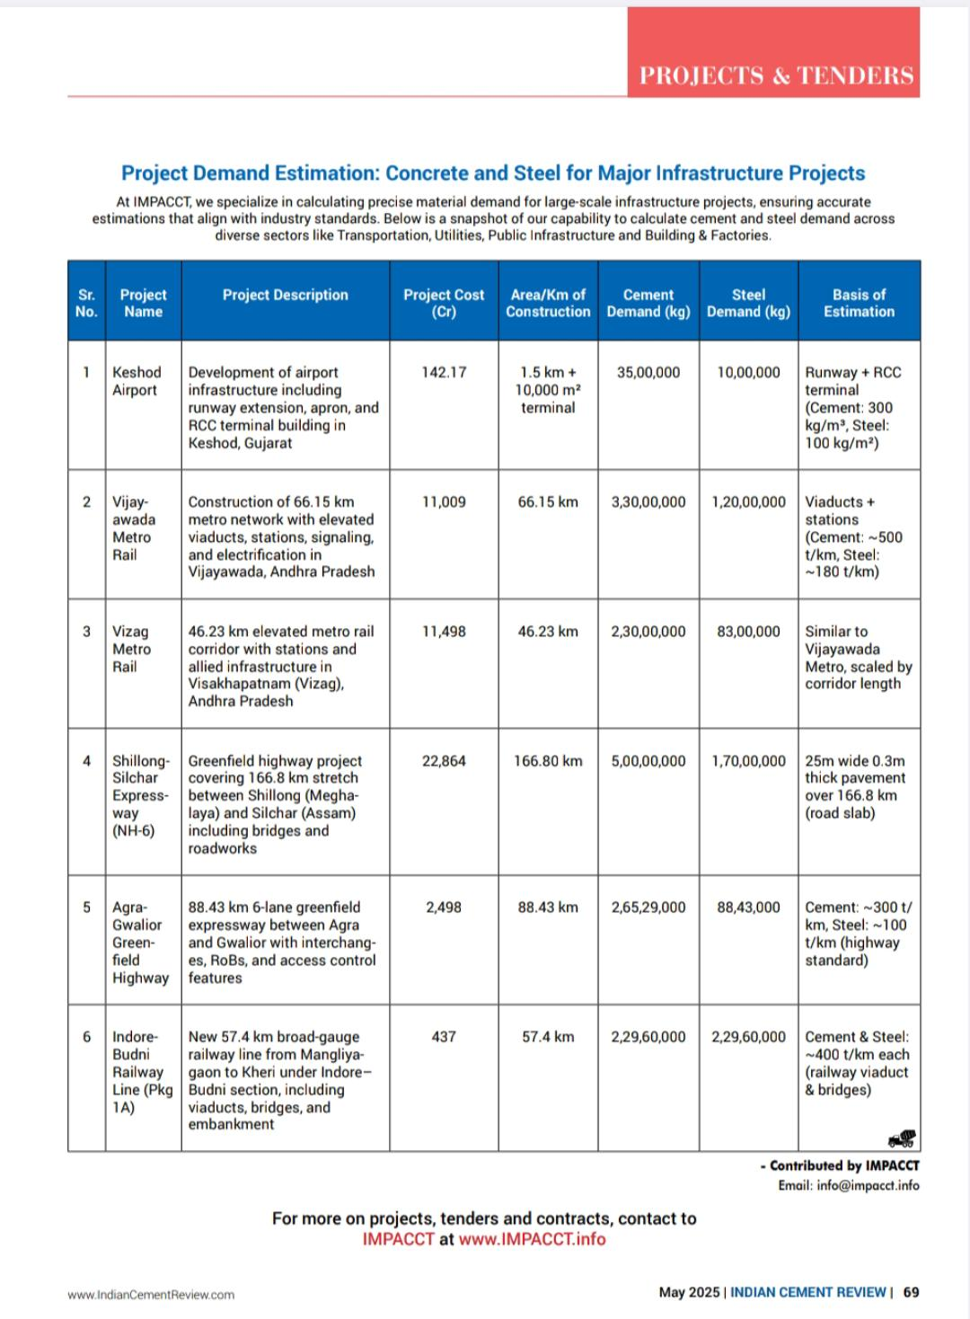

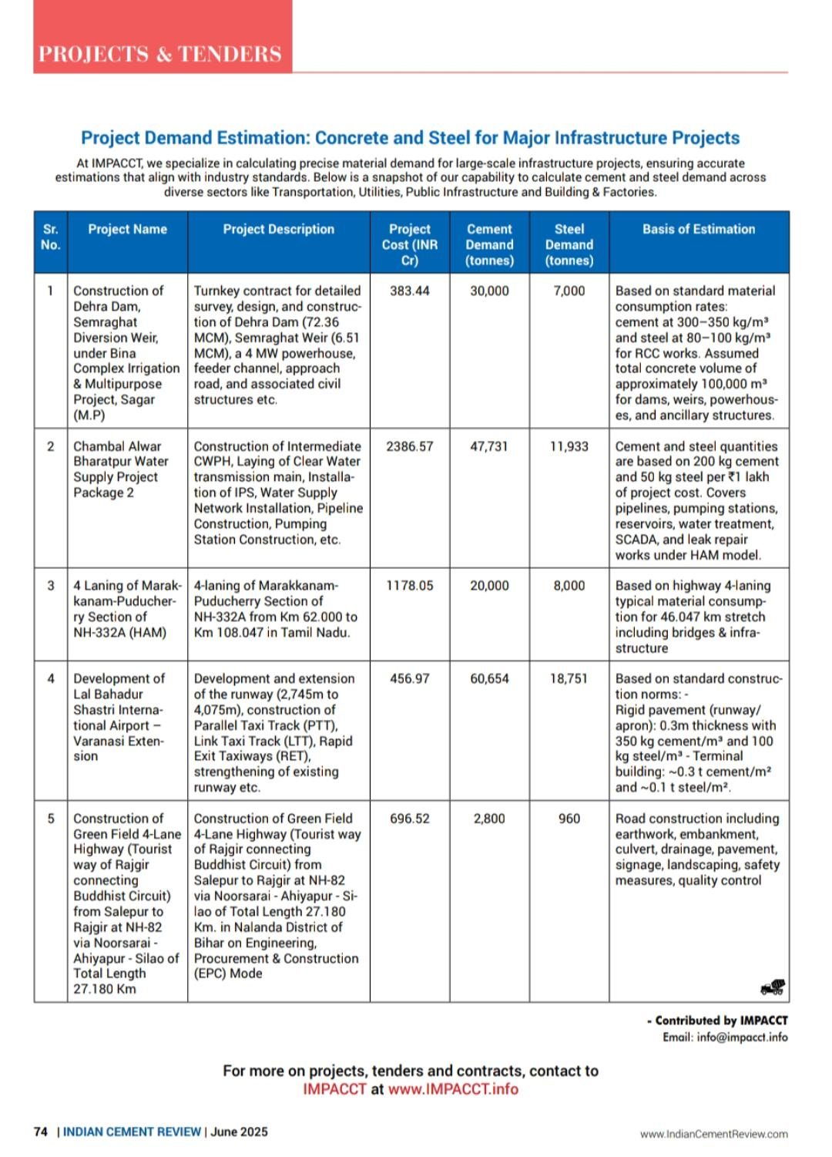

# **CHAPTER THREE**

# **KEY LEARNINGS**

The internship at ASAPP offered a multidimensional learning experience, combining technical rigor with strategic thinking, domain exposure, and professional development. The following key learnings reflect how this immersive experience transformed my understanding of infrastructure analytics and enriched my skill set:

**1. Technical Learnings**

1. **Web Scraping and Automation**

* Gained hands-on experience in scraping structured and semi-structured data from complex web portals.
* Applied advanced scraping techniques, including CAPTCHA handling, session management, and OCR.
* Understood the importance of ethical scraping and the role of data licensing in public platforms.

1. **Estimation Modeling**

* Learned to develop cement and steel demand estimation models using CPWD norms, IS codes, and tender data.
* Applied real-world thumb rules and validated outputs using statistical methods like Mean Absolute Deviation.
* Understood how estimation logic varies by sector and how different parameters (e.g., project value, area, type) influence material needs.

1. **Database and SQL Integration**

* Gained practical exposure to relational databases using HeidiSQL.
* Updated live database records with estimation outputs and catalogued data.
* Learned to link frontend dashboards with backend queries for dynamic reporting.

1. **AI and NLP Fundamentals**

* Designed logic trees and prompt templates for AI model integration.
* Used natural language processing to extract insights from unstructured text.
* Understood how AI can simplify tender classification, forecasting, and recommendation systems.

**2. Domain Learnings**

* Acquired a strong understanding of the Indian infrastructure ecosystem, including roads, metro, railways, utilities, and real estate.
* Learned how government tendering works how data is published, reviewed, awarded, and archived.
* Understood the role of regulatory bodies like RERA and MoEFCC and the value of environmental clearance data.
* Developed familiarity with public project lifecycles and the interplay between policy, procurement, and delivery.

**3. Business Intelligence and Visualization**

* Learned how to convert raw data into meaningful KPIs for decision-makers.
* Designed dashboard structures using charts, heatmaps, and trend analysis.
* Understood how to prioritize information based on user roles (e.g., analyst, executive, client).
* Recognized the importance of visual storytelling in strategic decision-making.

**4. Professional and Interpersonal Learnings**

1. **Team Collaboration and Communication**

* Participated in brainstorming sessions, knowledge-sharing workshops, and client interactions.
* Documented SOPs and trained new team members on estimation workflows.
* Improved articulation of technical concepts for both technical and non-technical stakeholders.

1. **Time and Task Management**

* Managed multiple projects in parallel with weekly tracking and feedback loops.
* Learned to prioritize tasks, meet deadlines, and maintain quality.
* Used versioning and documentation best practices to ensure clarity and reproducibility.

1. **Problem-Solving Mindset**

* Approached ambiguity with a structured mindset identifying root causes, experimenting with alternatives, and iterating quickly.
* Proposed scalable solutions and proactively optimized existing workflows.
* Learned to balance innovation with feasibility and time constraints.

**5. Holistic Perspective**

Perhaps the most invaluable learning was gaining a holistic understanding of how different disciplines converge in a data-driven infrastructure firm. From coding and estimation to cataloguing and AI, each task was a cog in a larger machine working toward the shared mission of building a smarter, faster, and more transparent infrastructure ecosystem.

These learnings, both tangible and intangible, will continue to guide me in future roles whether as a data analyst, infrastructure consultant, or product manager wherever insights, systems, and impact intersect.

# **CHAPTER FOUR**

# SUGGESTIONS AND RECOMMENDATIONS

Throughout my internship at ASAPP, I encountered opportunities for optimization across various stages of data handling, estimation modeling, AI integration, and knowledge sharing. Based on practical exposure, critical thinking, and collaborative brainstorming with the team, the following suggestions and recommendations are presented to enhance the functionality, scalability, and impact of ASAPP’s digital infrastructure platform:

**1. Refinement of RERA and EC Data Collection**

* **Invest in Hybrid Scraping Tools**: Combining automation (Python scripts) with semi-manual data input via OCR-assisted tools will increase accuracy and reduce time loss from inconsistent portals.
* **Create a RERA Portal Tracker Dashboard**: A central dashboard displaying status, challenges, and updates for each state's RERA scraping progress will help the team manage targets better.
* **Explore Legal Partnerships with RERA Bodies**: Formalize data-sharing agreements to get structured datasets directly from the source and avoid scraping limitations.

**2. Enhancement of Estimation Frameworks**

* **Incorporate Region-Based Multipliers**: Introduce state- or terrain-specific adjustment factors (e.g., hill zones, coastal zones) for cement and steel estimation models.
* **Historical Data Learning Engine**: Use completed project reports to calibrate multipliers and enrich the forecasting engine using machine learning.
* **Standard Error Reporting**: Display standard deviation or MAD range alongside estimates to reflect uncertainty and enhance transparency.

**3. Catalogue Structuring and Expansion**

* **Add Pricing and Availability APIs**: Link catalogue products with vendor APIs (e.g., IndiaMart, BuildSupply) to reflect dynamic pricing, lead time, and stock.
* **Sector-Specific Catalogues**: Build deep-dive catalogues for specialized sectors like tunneling, solar infrastructure, and smart cities.
* **Versioning and Review Logs**: Maintain logs for updates in product specifications or regulatory changes to ensure traceability.

**4. AI and Automation Recommendations**

* **Dedicated NLP Training Dataset**: Curate a proprietary dataset of tenders and project summaries for fine-tuning AI models specific to infrastructure.
* **Auto-Classification Confidence Scores**: Provide confidence scores when AI classifies a tender into a sub-sector or category to aid human review.
* **Automated Insights Layer**: Beyond estimations, AI can be trained to summarize risks, regulatory flags, and likely material bottlenecks from project descriptions.

**5. Team Processes and Knowledge Transfer**

* **Onboarding Manual and SOP Repository**: Build a structured onboarding guide for new hires/interns to reduce the learning curve.
* **Hackathons or Sprints**: Conduct monthly internal hackathons to generate innovative ideas around estimation accuracy, AI workflows, and UI design.
* **Cross-Team Integration Workshops**: Facilitate sessions where tech, domain, and content teams present their work to understand interdependencies better.

**6. Client and Stakeholder Interface Improvements**

* **Interactive Client Dashboards**: Provide clients with customized dashboards showing real-time demand forecasts, project tracking, and procurement suggestions.
* **Feedback Loop Mechanism**: Create a feedback channel where clients or users can rate AI outputs and forecasts, enabling reinforcement learning for better future predictions.
* **Sectoral Intelligence Reports**: Automate monthly reports summarizing top tenders, new regulations, and material demand per state or sector for client circulation.

These recommendations are aimed at reinforcing ASAPP’s core strengths data intelligence, estimation accuracy, and innovation while opening new pathways for scalability, transparency, and user engagement. Implementing even a few of these changes could significantly streamline operations and position ASAPP Info Global Services Pvt. Ltd as a leader in the infrastructure analytics domain.

# **CHAPTER FIVE**

# CONCLUSION

Reflecting on my internship at ASAPP, I recognize this experience as one of the most transformative chapters in my academic and professional journey. It was not merely an opportunity to apply technical skills, but a deeply enriching process that broadened my perspective on how data, policy, infrastructure, and innovation interconnect in the real world.

From deciphering unstructured data on government portals to predicting material demands for mega infrastructure projects, every task challenged me to push my analytical boundaries. I learned to navigate complexities be it scraping dynamic web structures, calibrating estimates across diverse project types, or bridging the gap between AI logic and infrastructure context. More importantly, I learned how to transform these challenges into opportunities by using critical thinking, domain understanding, and collaboration.

ASAPP provided an ideal platform where innovation was encouraged, exploration was supported, and mistakes were treated as stepping stones. I was given the autonomy to design frameworks, suggest improvements, lead minor modules, and contribute meaningfully to ongoing projects that are shaping how infrastructure is tracked and planned across India.

This experience has not only solidified my passion for data-driven development but has also prepared me to take on complex roles in infrastructure analytics, public systems, or technology consulting. I now carry with me a toolkit enriched with practical skills, industry exposure, and a strategic mindset. As I transition into the next phase of my career, I am confident that the foundation built here will serve as a compass for both professional excellence and meaningful impact.

In conclusion, the internship at ASAPP Info Global Services Pvt. Ltd was far more than a learning program it was a deep dive into the mechanics of digital infrastructure transformation. I am grateful for the mentorship, the challenges, and the trust placed in me. I leave this internship more informed, more inspired, and ready to contribute to the future of infrastructure intelligence.

# **REFERENCES**

|  |
| --- |
|  |

# **APPENDIX**

**WEEKLY REPORTS**

**Internship Weekly Activity Report Week 1**

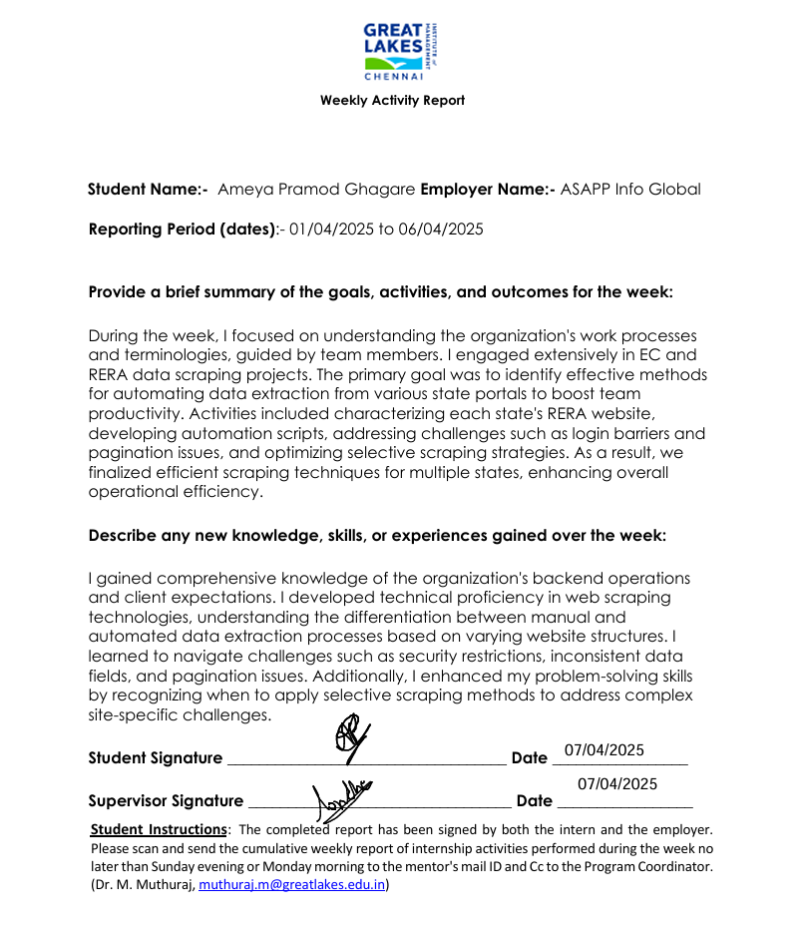

**Internship Weekly Activity Report Week 2**

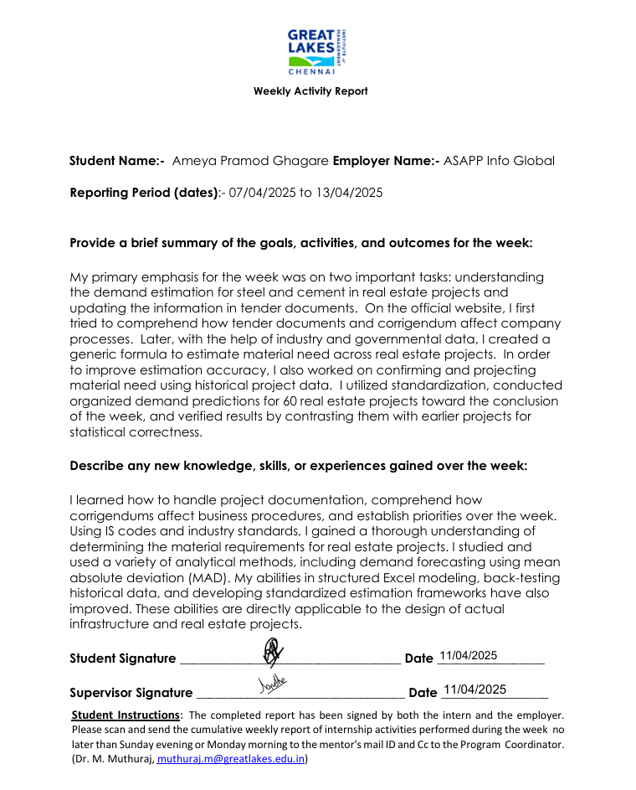

**Internship Weekly Activity Report Week 3**

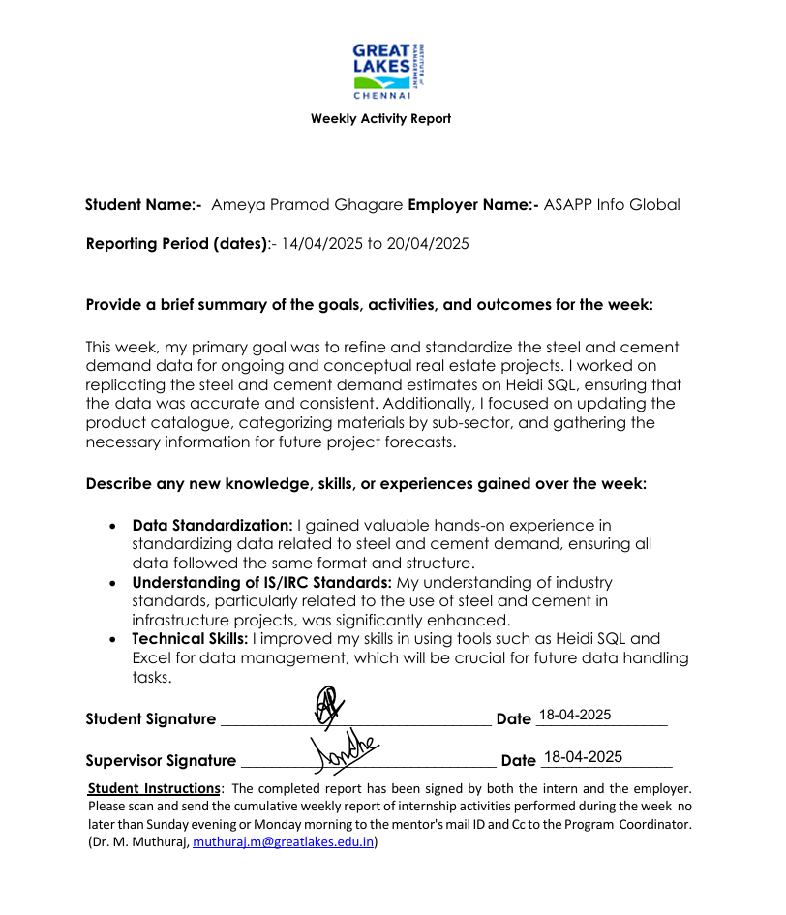

**Internship Weekly Activity Report Week 4**

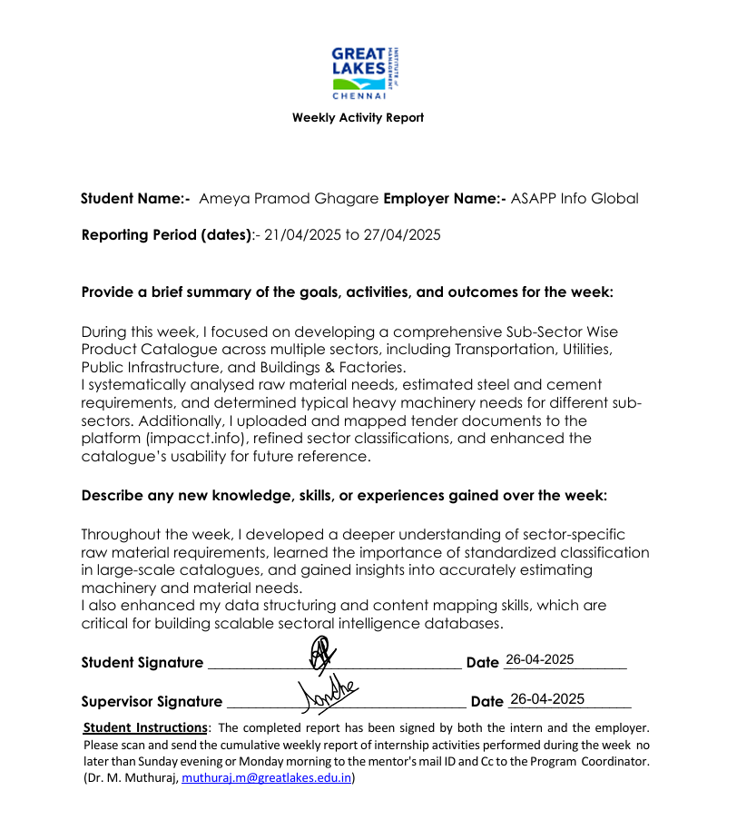

**Internship Weekly Activity Report Week 5**

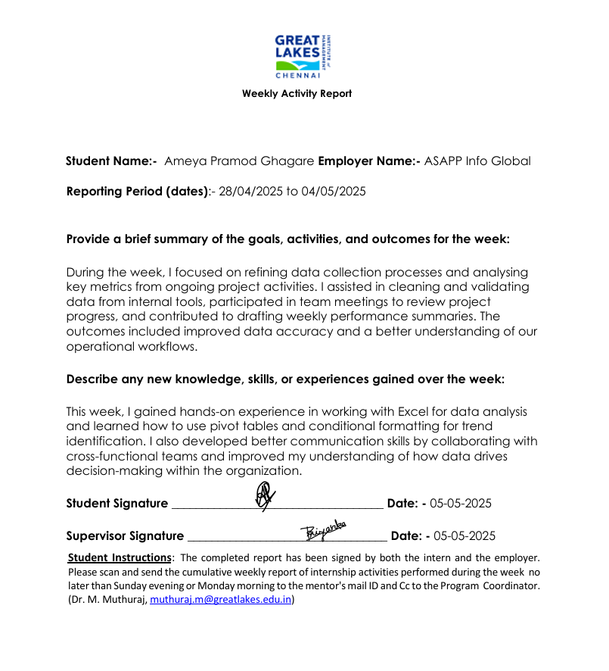

**Internship Weekly Activity Report Week 6**

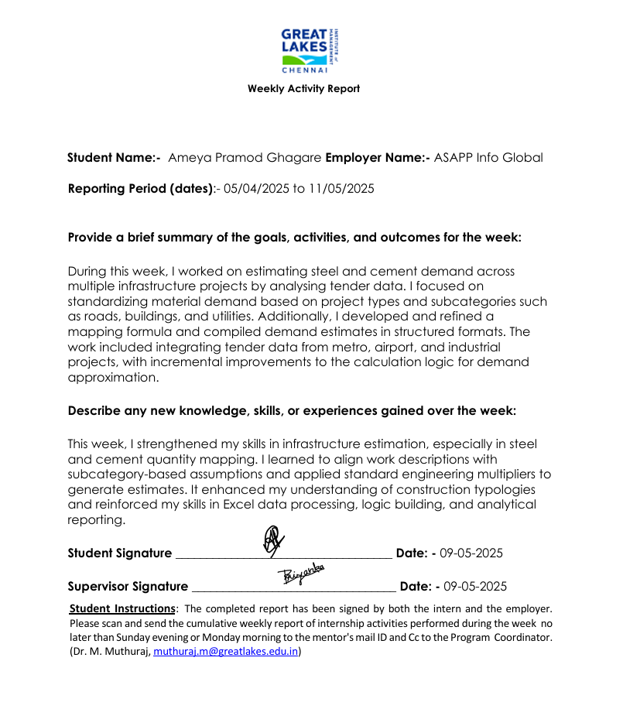

**Internship Weekly Activity Report Week 7**

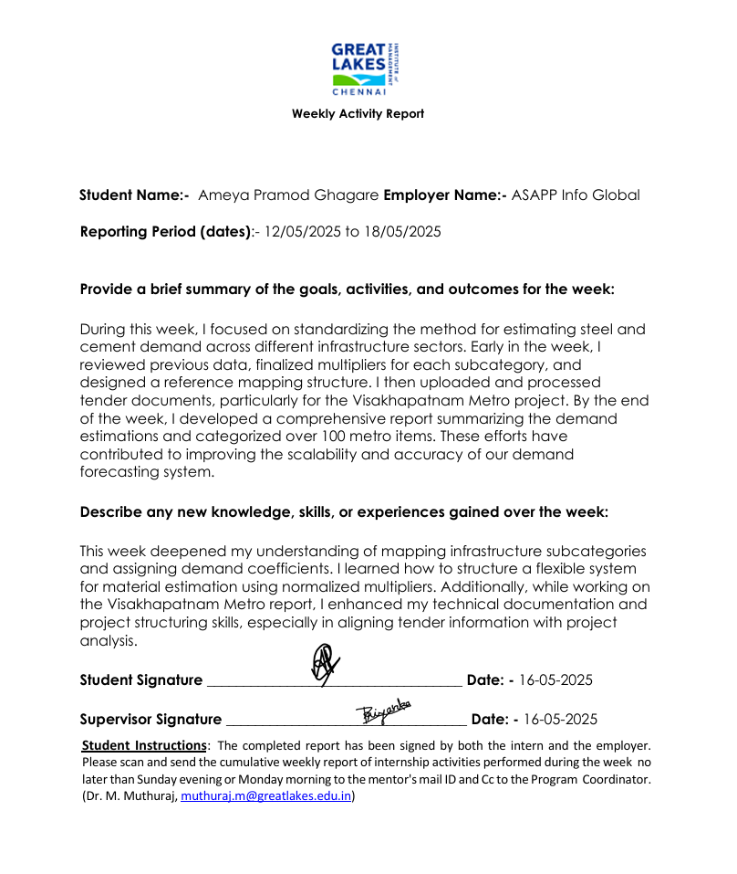

**Internship Weekly Activity Report Week 8**

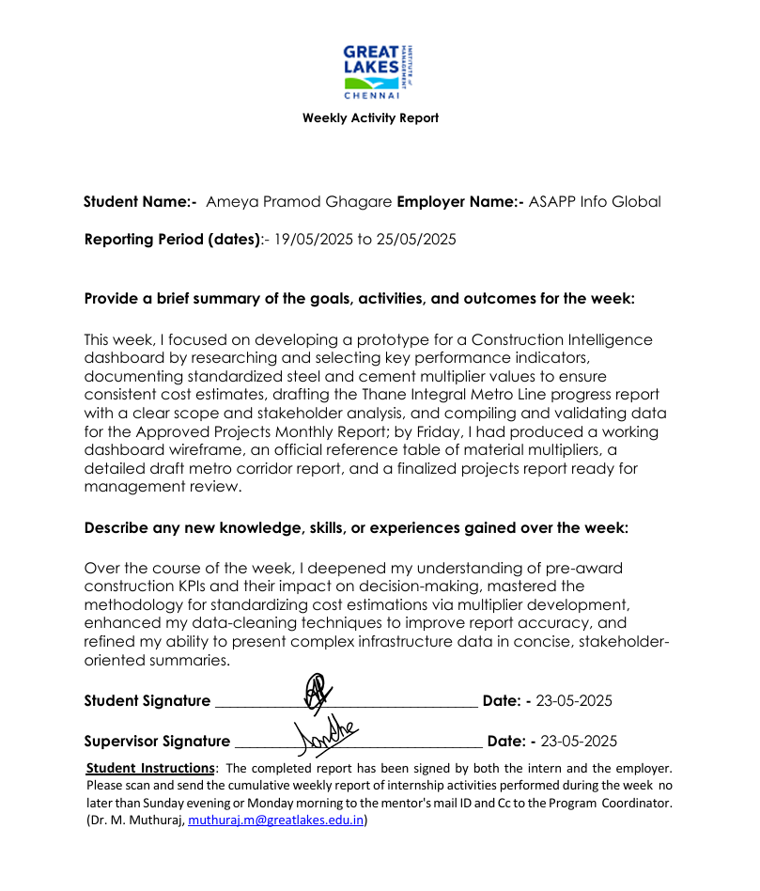

**Internship Weekly Activity Report Week 9**

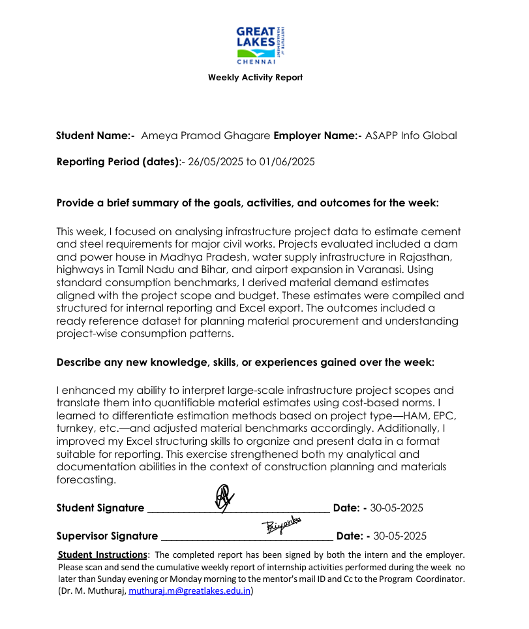

**Internship Weekly Activity Report Week 10**

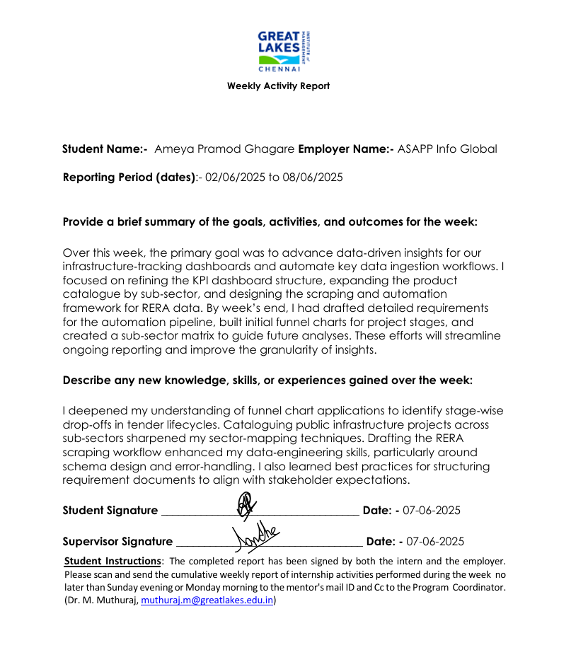

**Internship Weekly Activity Report Week 11**

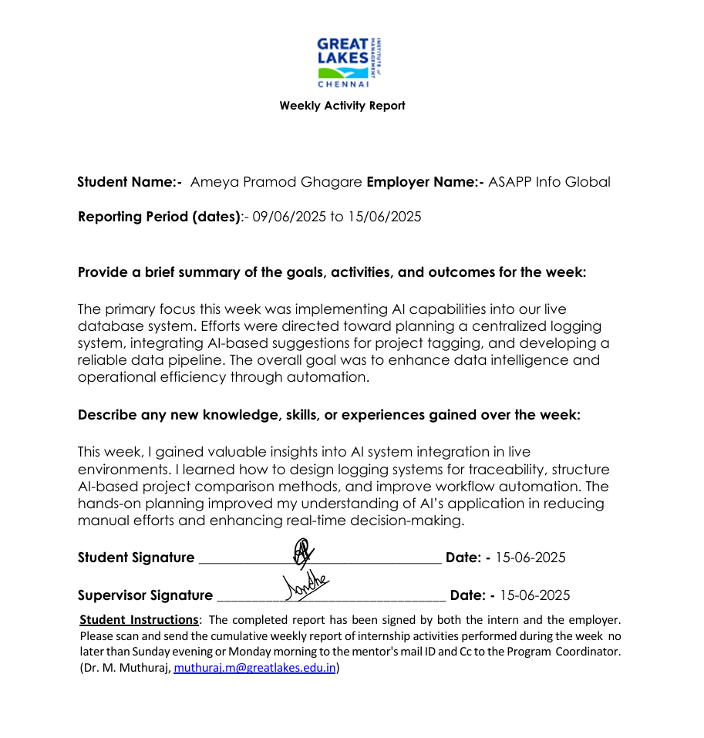

**Internship Weekly Activity Report Week 12**

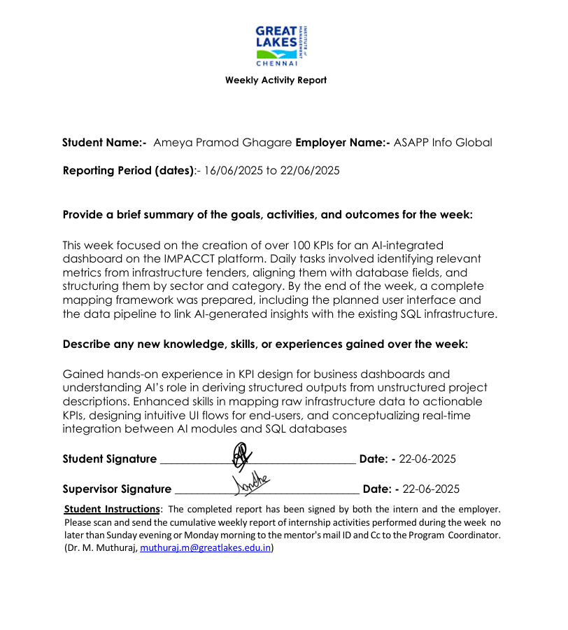

**Internship Weekly Activity Report Week 13**

